WOMEN’S UNIVERSITY IN
AFRICA


Addressing gender disparity and fostering equity in University Education
FACULTY OF MANAGEMENT AND ENTREPRENEURIAL
SCIENCES

GROUP PROJECT

NAMES STUDENT ID
NOMSA WIZALAMU W251190
AUXILLIA TENDAYI W250248
TANYARADZWA K MUGWAGWA W251718
TRISTAN

LAB 1

QUESTION 1.1
Create a GitHub repository named wua-food-delivery. Initialize it with a README, .gitignore (for Python/Node.js), and a LICENSE file (MIT).
Provide the repository URL

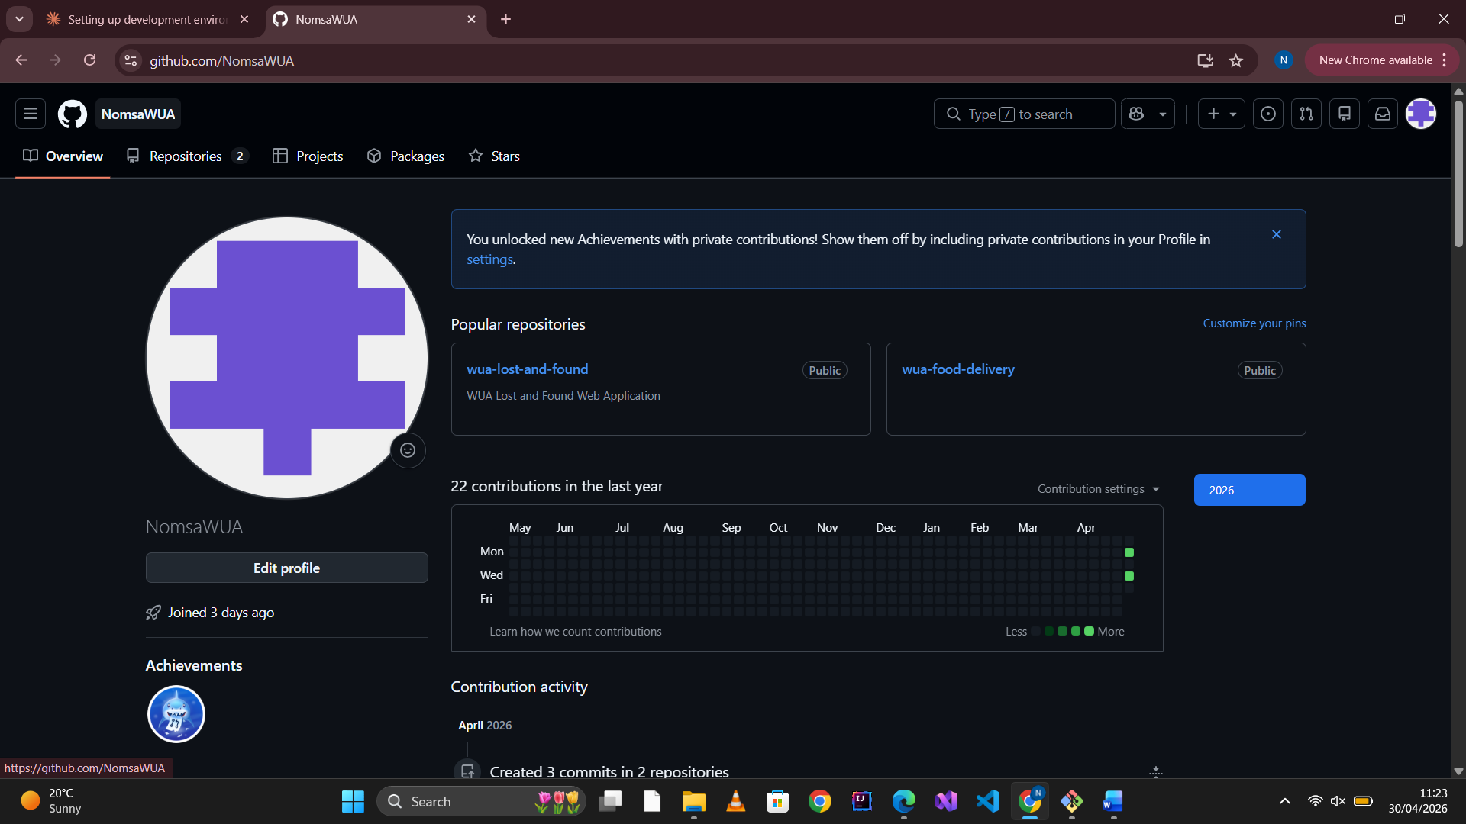
https://github.com/NomsaWUA/wua-food-delivery

QUESTION 1.2
Clone the repository to your local machine. Configure Git globally with your name and university email. Run git config --list and capture the output.

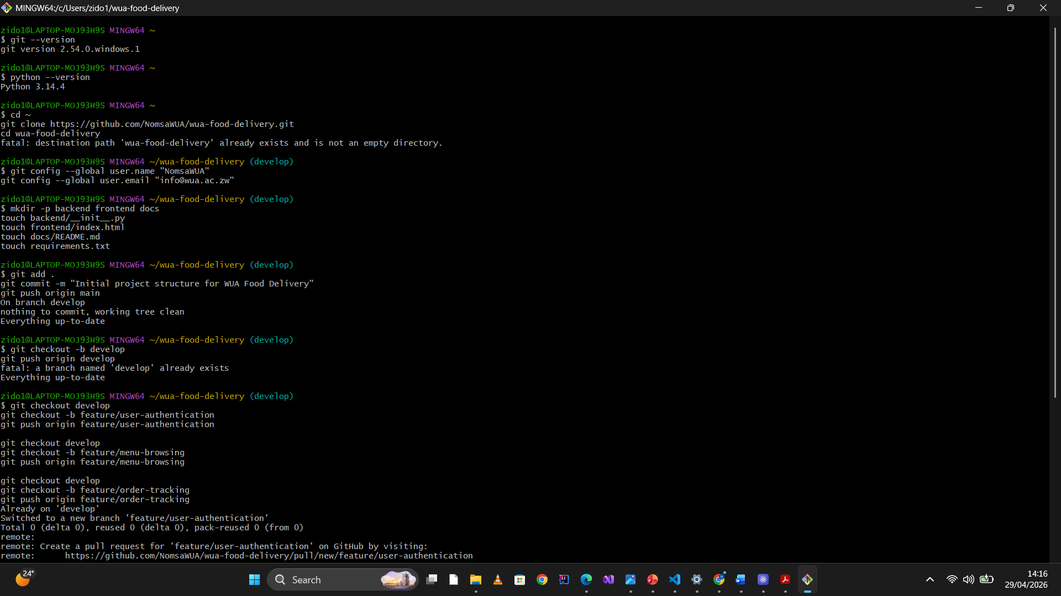

Question 1.3:
Create the following directory structure and files:
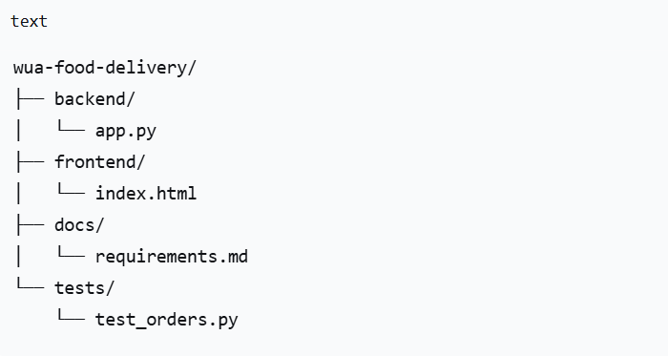
Stage and commit these files with the message: "Initial project structure for WUA Food Delivery"
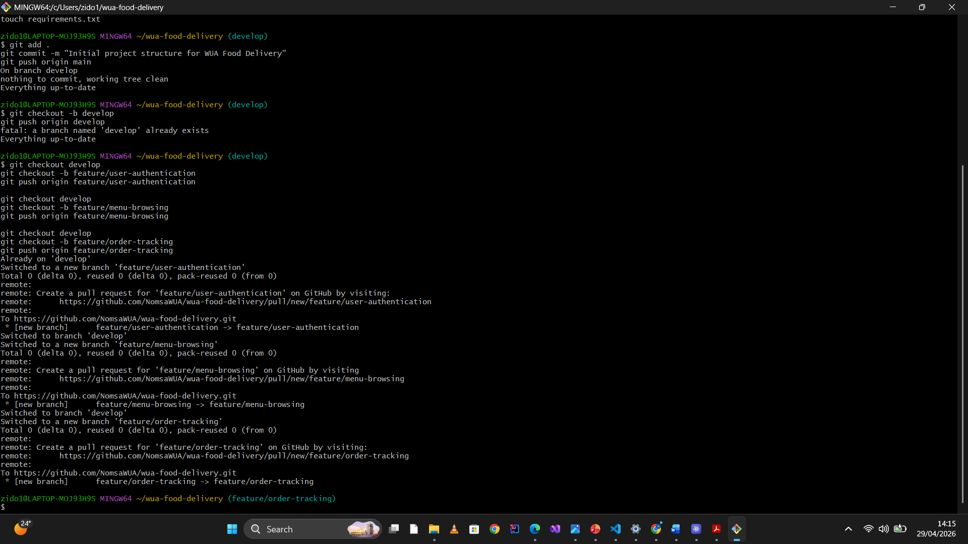
Question1.4:
Create a develop branch from main. Push both branches to GitHub. Provide screenshots showing both branches exist.

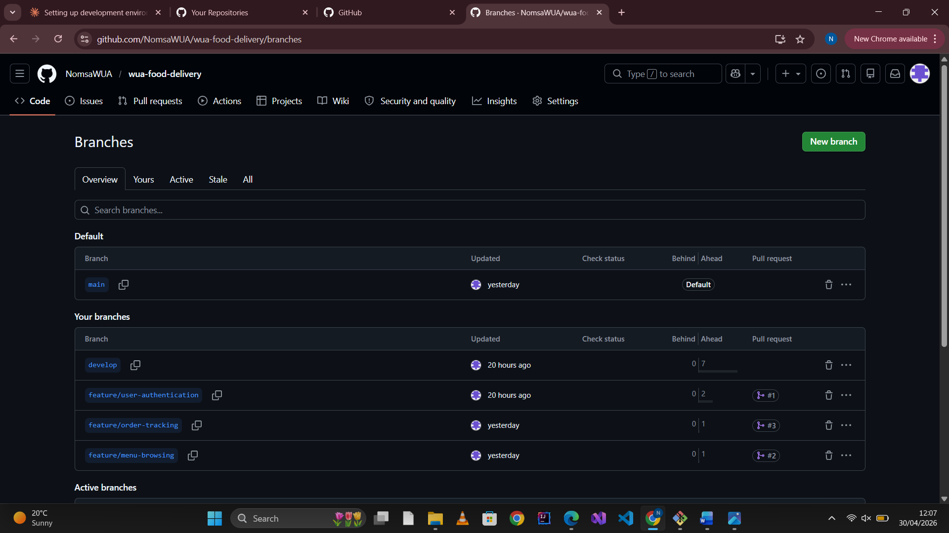

LAB 2
Question 2.1:
Create three feature branches from develop:
- feature/user-authentication
- feature/menu-browsing
- feature/order-tracking
Commands used:
bash
git checkout develop
git checkout -b feature/user-authentication
git push origin feature/user-authentication

git checkout develop
git checkout -b feature/menu-browsing
git push origin feature/menu-browsing

git checkout develop
git checkout -b feature/order-tracking
git push origin feature/order-tracking
Branch links:
https://github.com/NomsaWUA/wua-food-delivery/tree/feature/user-authentication
https://github.com/NomsaWUA/wua-food-delivery/tree/feature/menu-browsing
https://github.com/NomsaWUA/wua-food-delivery/tree/feature/order-tracking

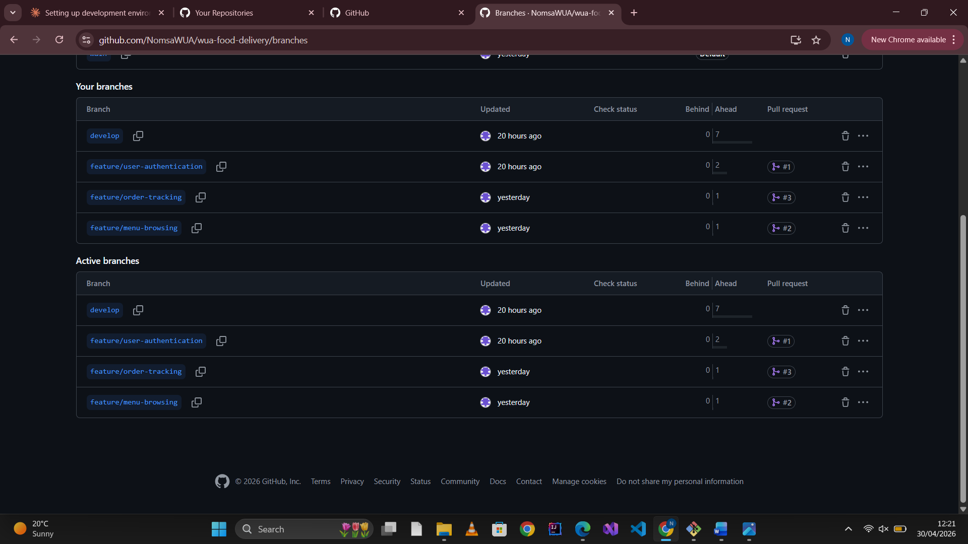
Question 2.2:
On feature/user-authentication, create a file backend/auth.py with:
- Function register_user(name, email, student_id, password)
- Function login_user(email, password)
Commit with message: "Add user authentication functions"
Commands used:
- git checkout feature/user-authentication
- cat > backend/auth.py << 'EOF'
- def register_user(name, email, student_id, password):
- print(f"Registering {name} with email {email}")

- def login_user(email, password):
- print(f"Logging in {email}")
- EOF
- git add backend/auth.py
- git commit -m "Add user authentication functions"
- git push origin feature/user-authentication

Link to file on GitHub:
https://github.com/NomsaWUA/wua-food-delivery/blob/feature/user-authentication/backend/auth.py
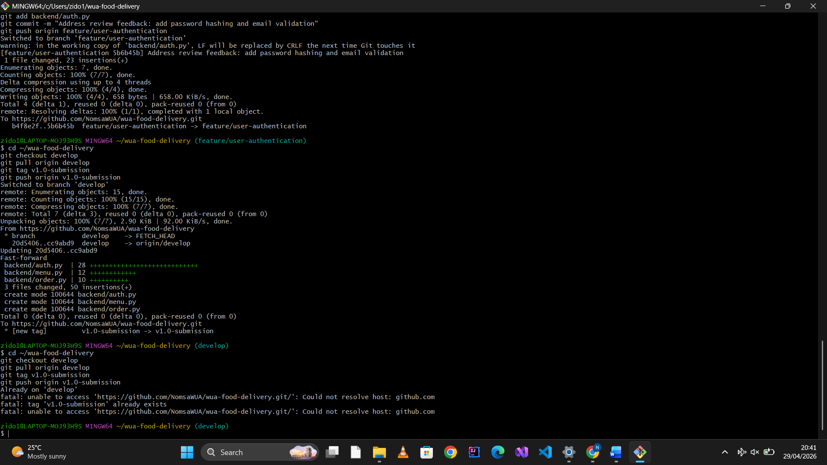
Question 2.3:
On feature/menu-browsing, create backend/menu.py with:
- Dictionary containing at least 5 food items with prices
- Function get_menu(cafeteria_name)
Commit with message: "Implement menu browsing feature"
Commands used:
git checkout feature/menu-browsing
cat > backend/menu.py << 'EOF'
menu_items = {
"Sadza & Beef Stew": 3.50,
"Chicken Burger": 2.00,
"Vegetable Rice": 1.50,
"Fish & Chips": 4.00,
"Fruit Salad": 1.00
}

def get_menu(cafeteria_name):
print(f"Menu for {cafeteria_name}:")
for item, price in menu_items.items():
print(f" {item}: ${price}")
EOF
git add backend/menu.py
git commit -m "Implement menu browsing feature"
git push origin feature/menu-browsing
Link to file on GitHub:
https://github.com/NomsaWUA/wua-food-delivery/blob/feature/menu-browsing/backend/menu.py

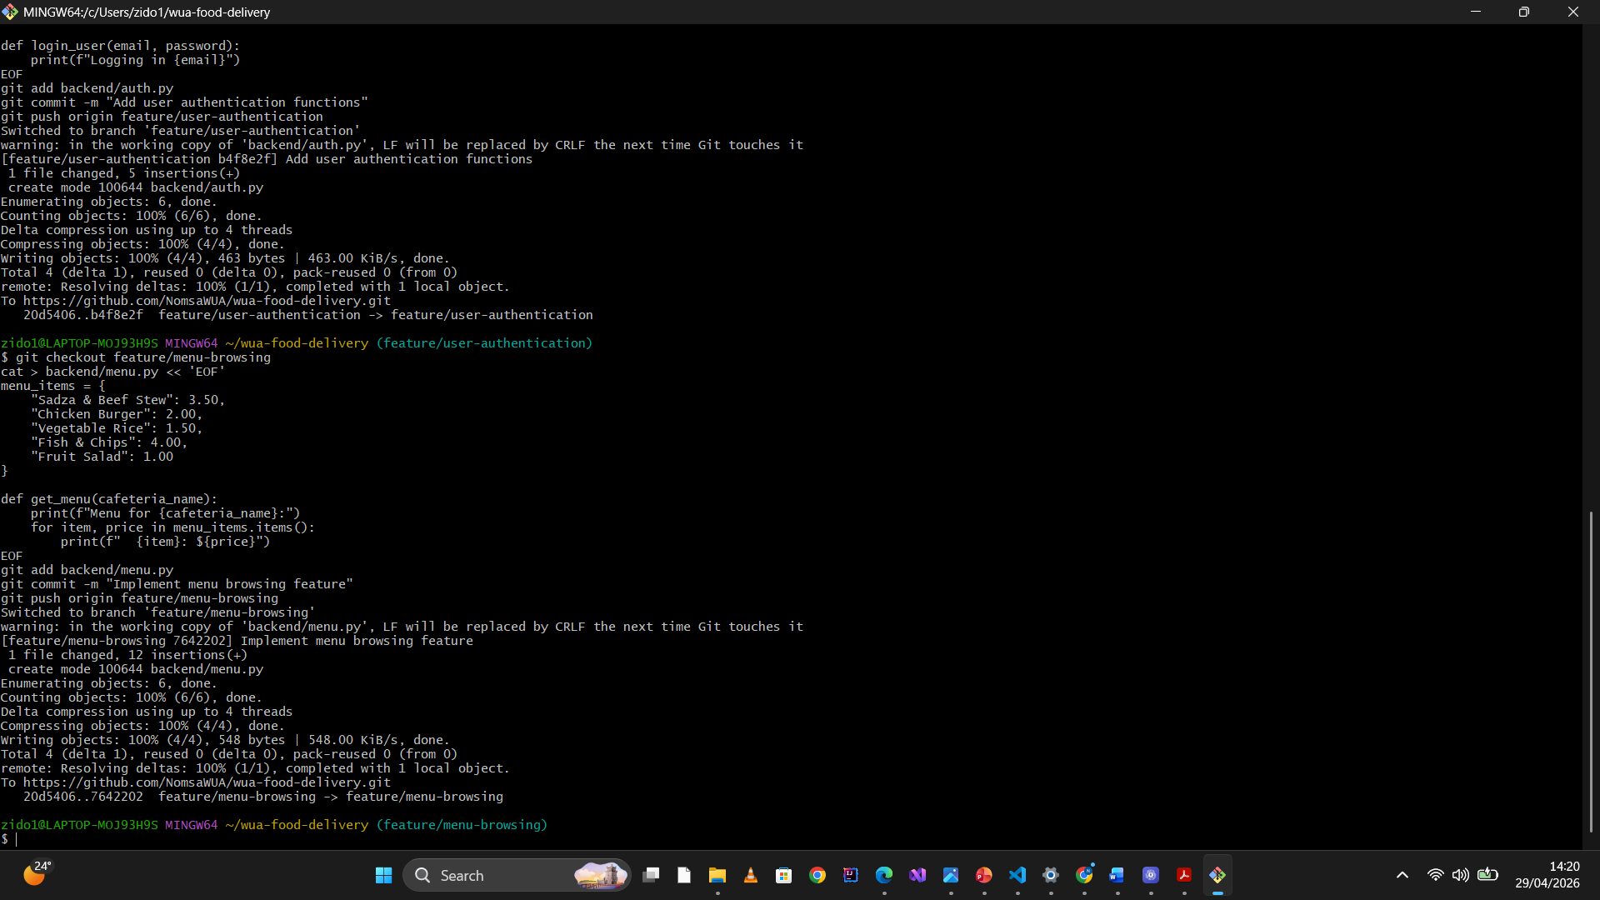

Question 2.4:
On feature/order-tracking, create backend/order.py with:
- Class Order with attributes: order_id, student_id, items, total_price, status
- Function update_order_status(order_id, new_status)
Commit with message: "Add order tracking functionality"

Commands used:
git checkout feature/order-tracking
cat > backend/order.py << 'EOF'
class Order:
def __init__(self, order_id, student_id, items, total_price, status):
self.order_id = order_id
self.student_id = student_id
self.items = items
self.total_price = total_price
self.status = status

def update_order_status(order_id, new_status):
print(f"Order {order_id} status updated to {new_status}")
EOF
git add backend/order.py
git commit -m "Add order tracking functionality"
git push origin feature/order-tracking

Link to file on GitHub:
https://github.com/NomsaWUA/wua-food-delivery/blob/feature/order-tracking/backend/order.py
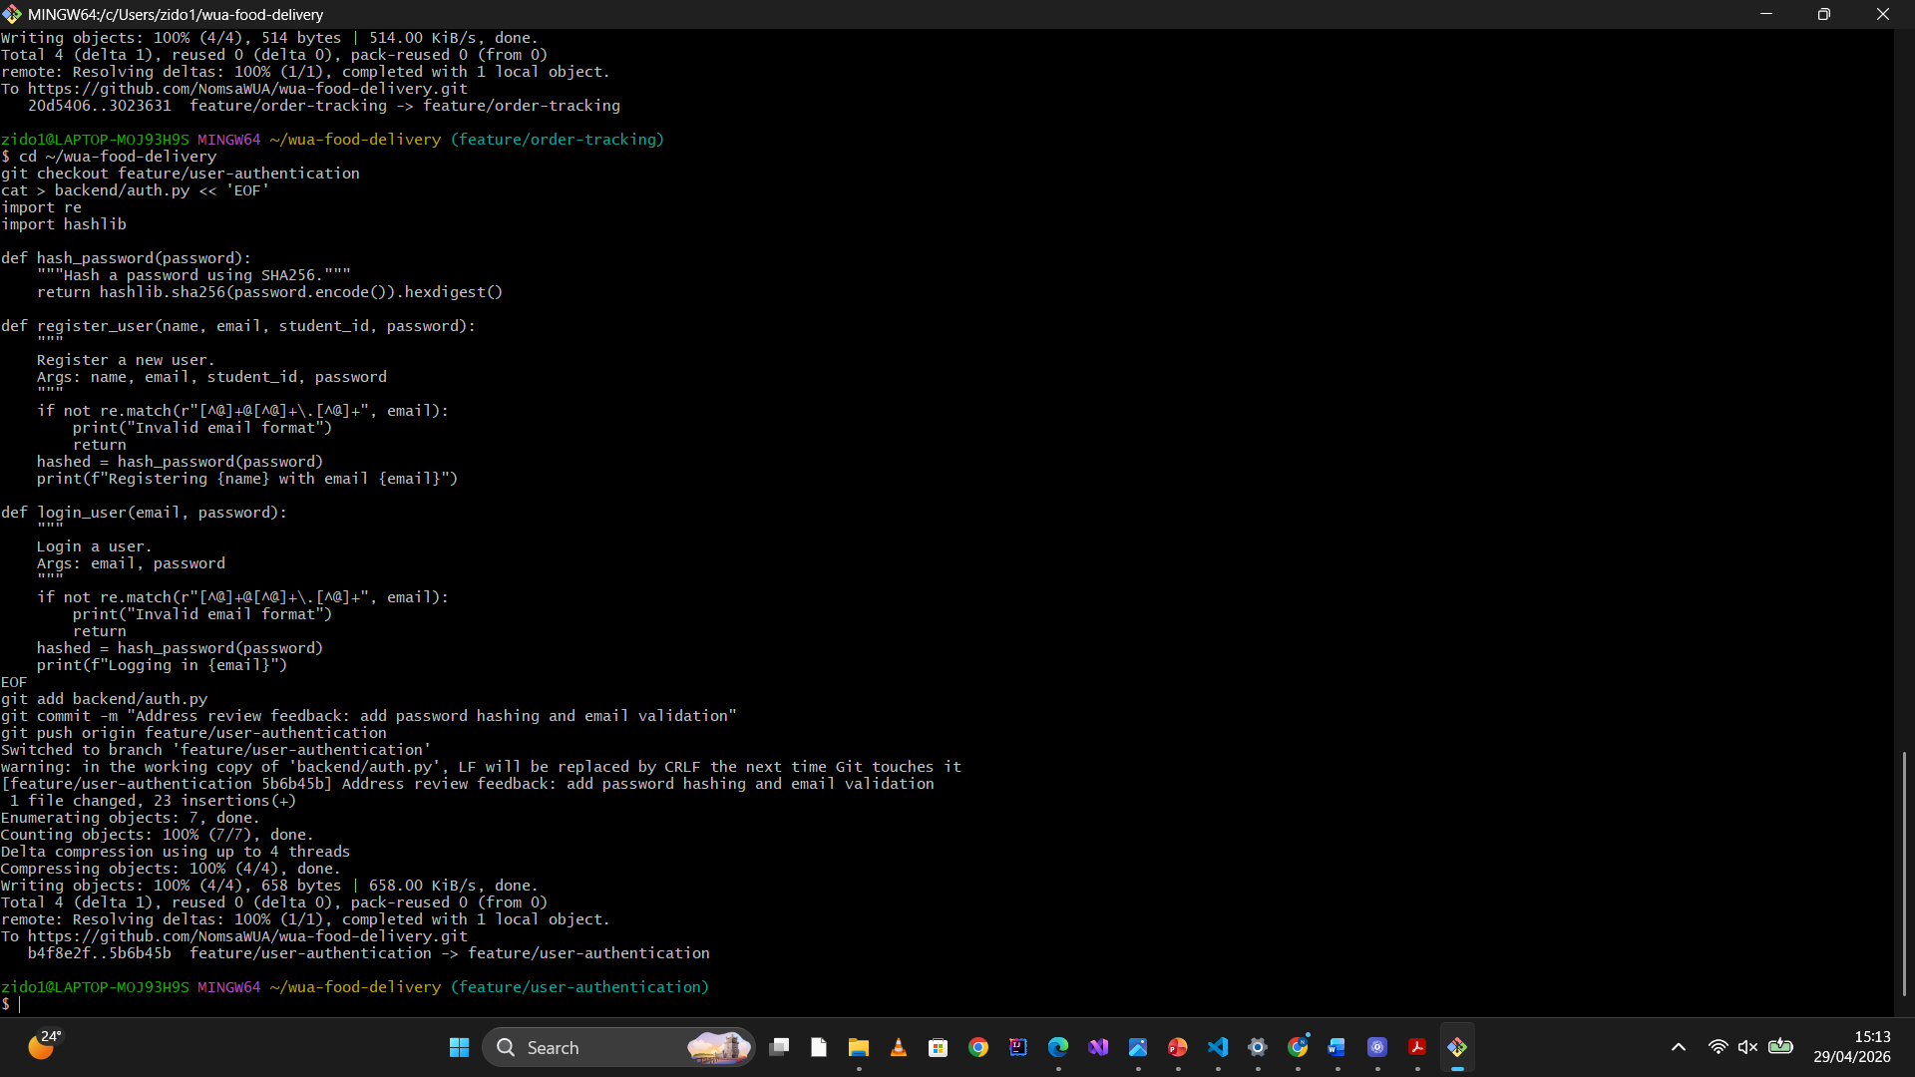

Question 2.5:
Push all three branches to GitHub. Provide the commands used and GitHub links for each branch.
Commands used:
git push origin feature/user-authentication
git push origin feature/menu-browsing
git push origin feature/order-tracking

GitHub Branch Links:
feature/user-authentication:
https://github.com/NomsaWUA/wua-food-delivery/tree/feature/user-authentication

feature/menu-browsing:
https://github.com/NomsaWUA/wua-food-delivery/tree/feature/menu-browsing

feature/order-tracking:
https://github.com/NomsaWUA/wua-food-delivery/tree/feature/order-tracking
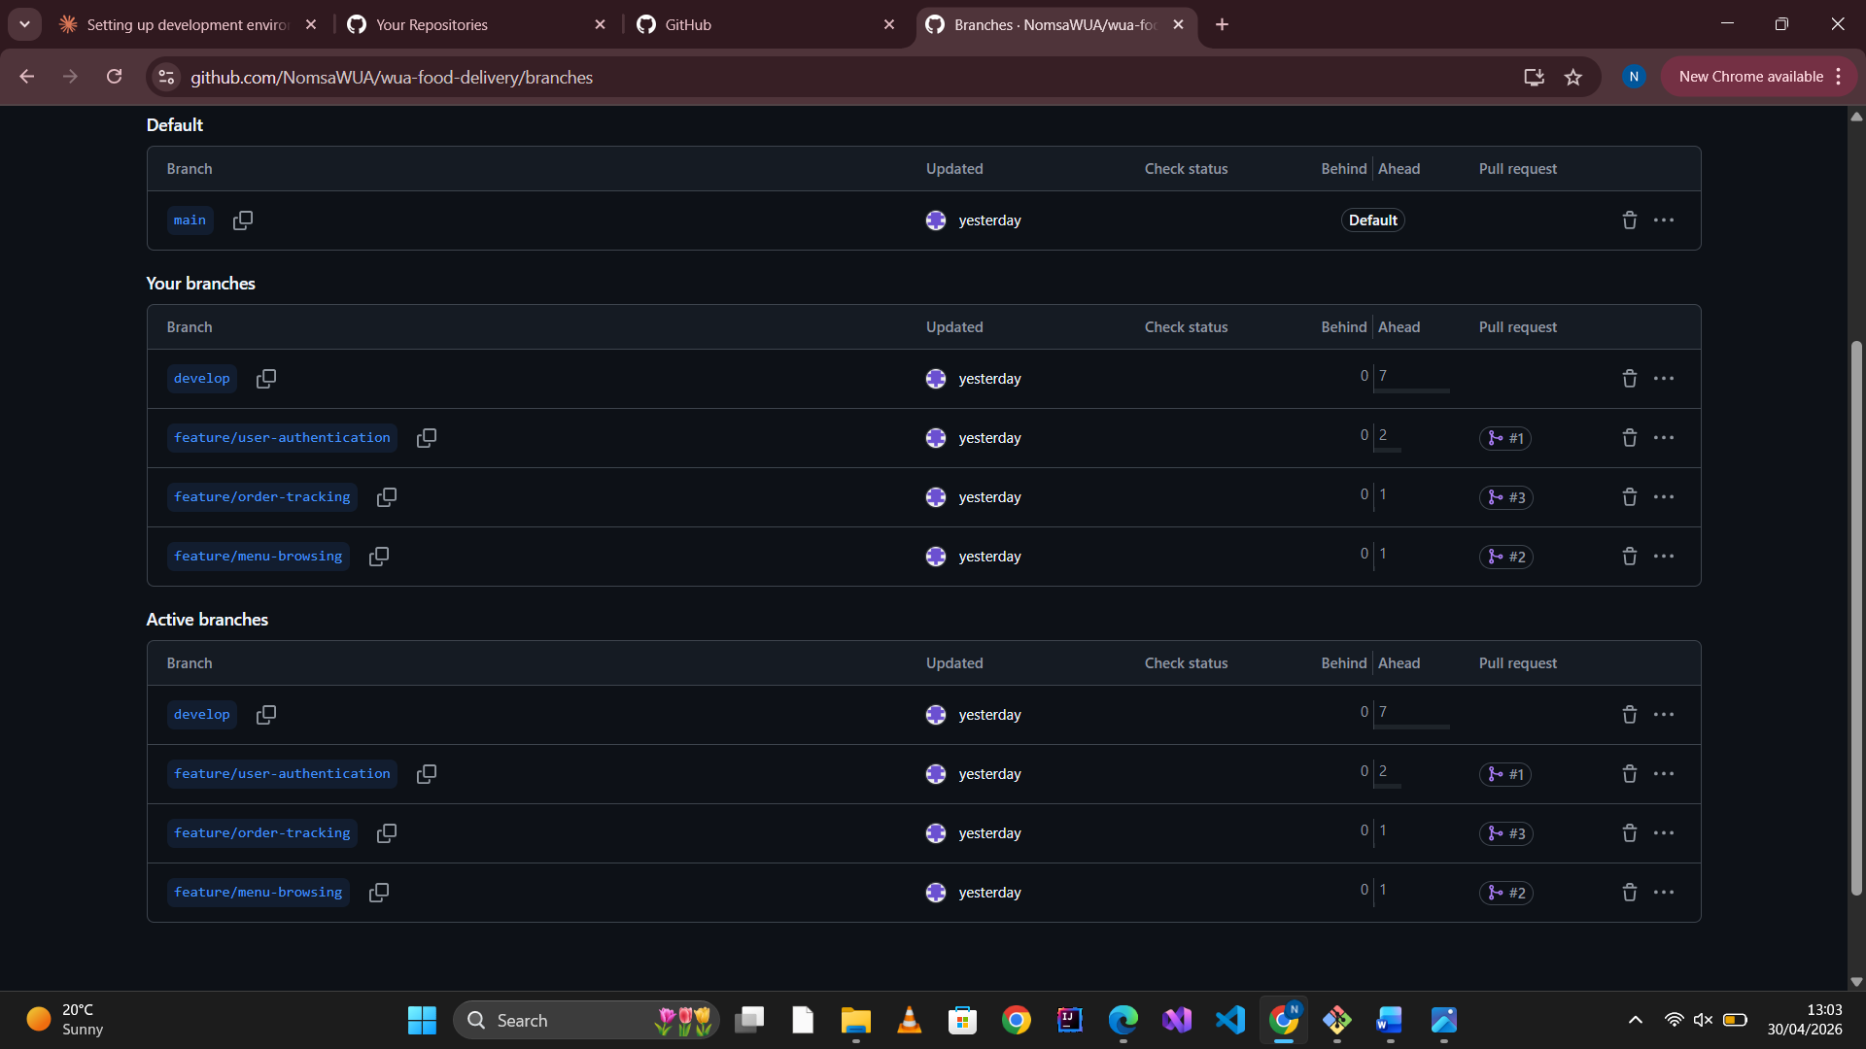

LAB 3
Question 3.1:
Create a Pull Request (PR) for feature/user-authentication into develop. Include:
- Title: "Add user authentication module"
- Description: List 3 changes made
- Labels: enhancement, backend
- Assign a team member as reviewer
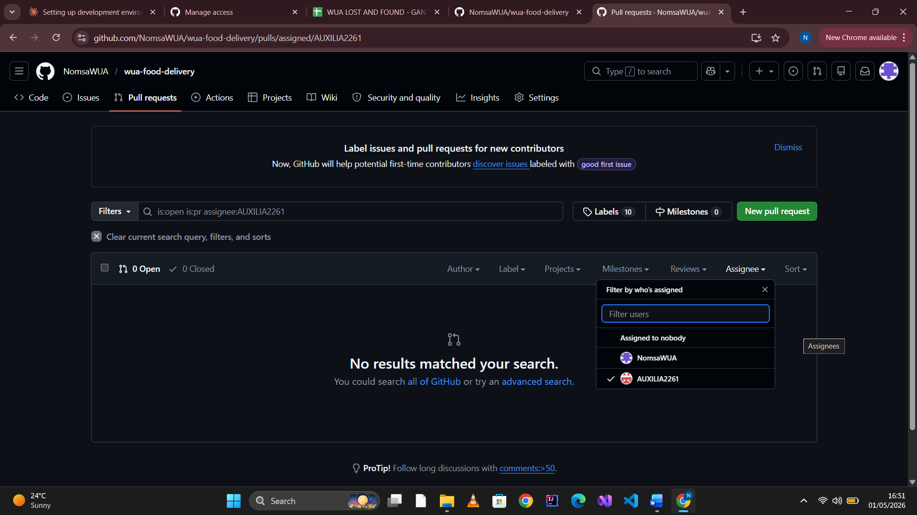
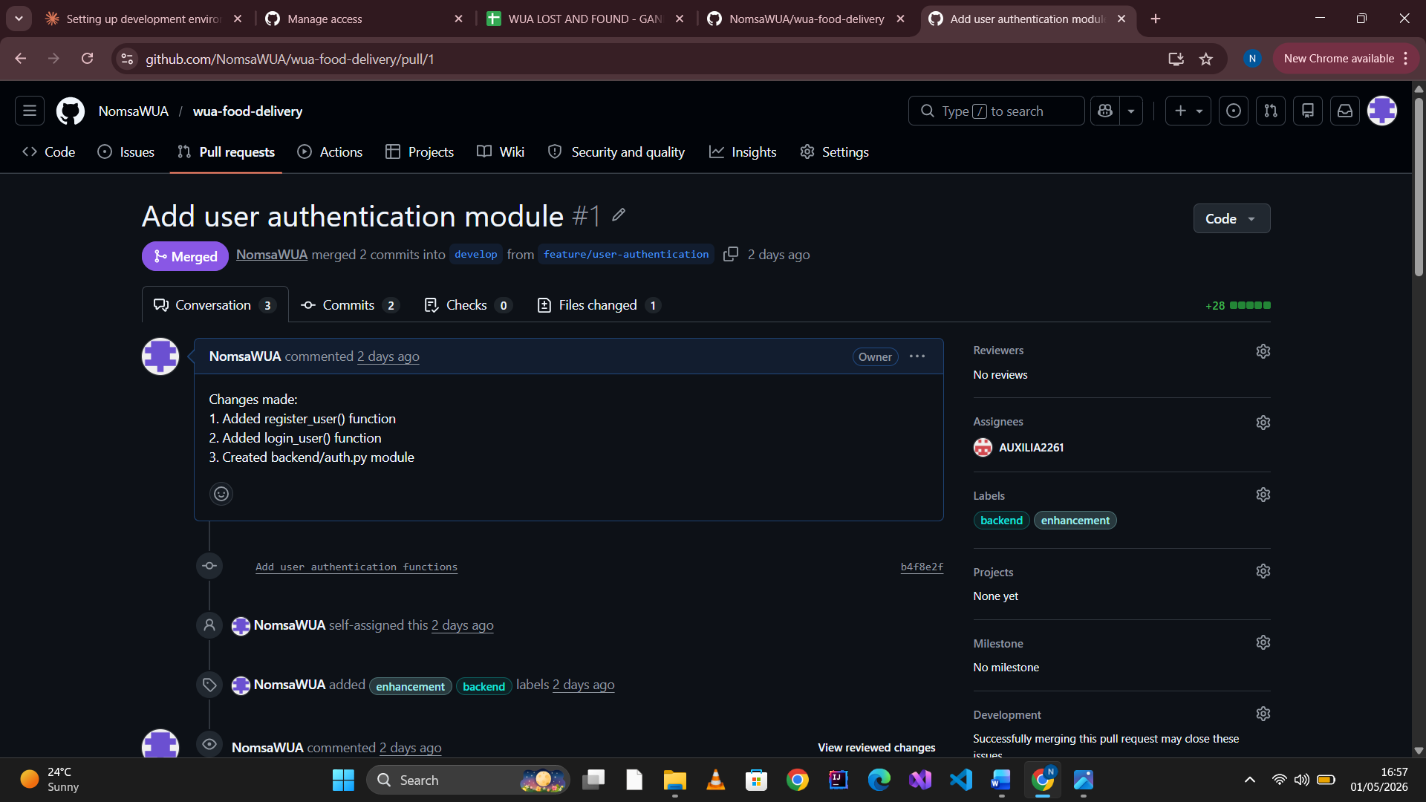

https://github.com/NomsaWUA/wua-food-delivery/pull/1

Question 3.2:
As the reviewer, add at least 3 code review comments on the PR. Examples:
- Suggest input validation for email format
- Recommend hashing passwords instead of plain text
- Propose adding docstrings

Question 3.4:
Merge the PR into develop only after all comments are resolved. Provide the merged PR link.

LAB 4
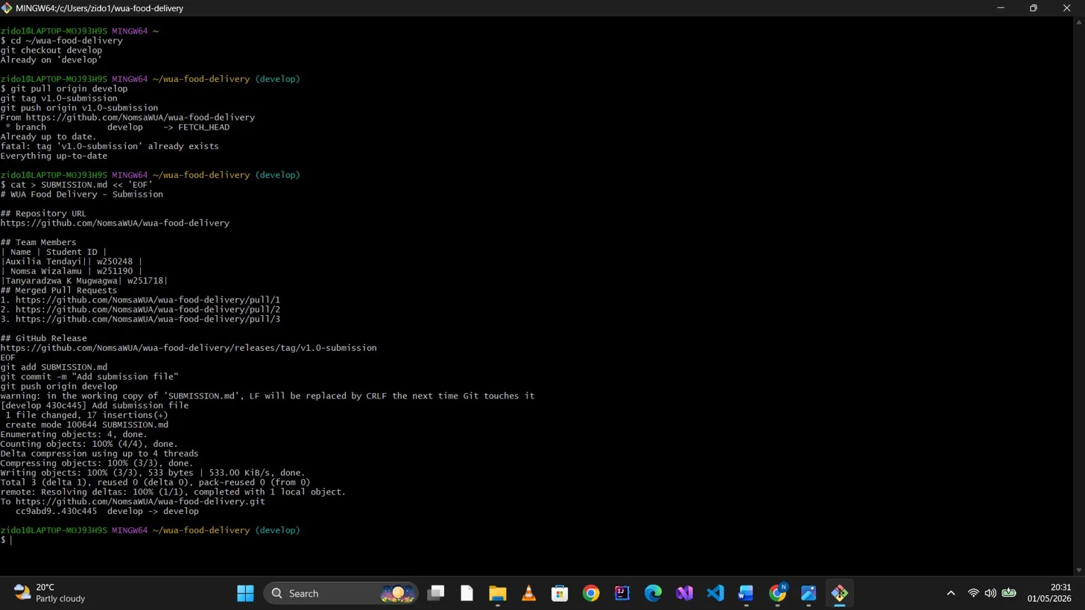

GIT REFLECTION

1. What Git challenges did your team face?
We faced merge conflicts when working on the same files
and difficulty coordinating branch merges.

2. How did you resolve merge conflicts?
We communicated via WhatsApp and resolved conflicts by
pulling latest changes before pushing.

3. What did we learn about teamwork using Git?
We learned the importance of branching strategies and
clear commit messages for collaboration.

4. How will you use Git differently in future?
We will create more frequent commits and use
descriptive branch names.

GitHub Release;
https://github.com/NomsaWUA/wua-food-delivery/releases/tag/v1.0-submission

CONTRIBRTORS GRAPH
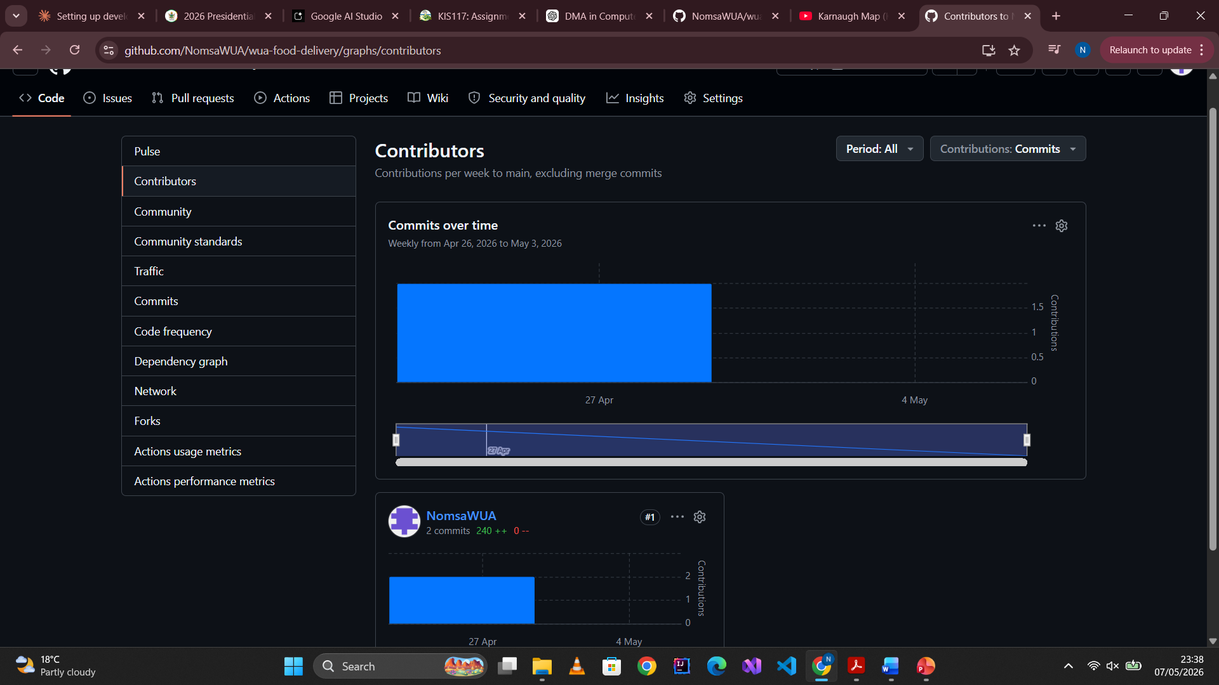

LINKS

Repo: https://github.com/NomsaWUA/wua-food-delivery
PR#1: https://github.com/NomsaWUA/wua-food-delivery/pull/1
PR#2: https://github.com/NomsaWUA/wua-food-delivery/pull/2
PR#3: https://github.com/NomsaWUA/wua-food-delivery/pull/3
Release: https://github.com/NomsaWUA/wua-food-delivery/releases/tag/v1.0-submission

